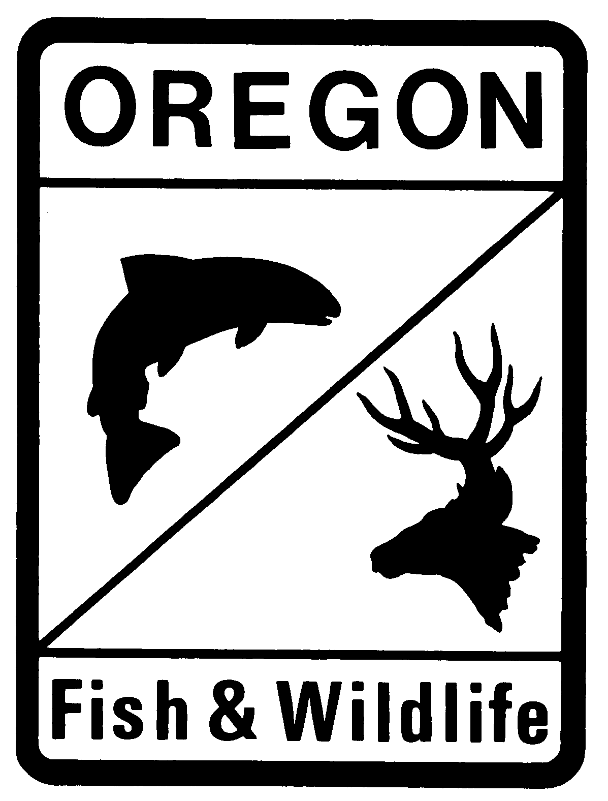
Oregon Department of Fish and Wildlife
Application for Environmental Restoration Weirs (ERW)

Project Name:
Date Work Will Begin:
Date work will be completed:

Applicant Information

Property Owner: Title:
Organization:
Address:
City: State: Zip:
E-Mail Address:

Signature: __________________________________________________ Date: _____________

Authorized Agent: Title:
Organization:
Address:
City: State: Zip:
E-Mail Address:

Signature: __________________________________________________ Date: _____________

Project Location

County:
River/Stream: Tributary Of:

Please note that the applicant or owner of the environmental restoration weir shall at all times observe and comply with all federal and state laws, including without limitation the Endangered Species Act of 1973, as amended (16 U.S.C. 1531-1536, 1538-1540), ORS 496.172 to 496.192 (Threatened and Endangered Wildlife Species), and ORS 564.100 to 564.135 (Threatened and Endangered Plants), and lawful regulations issued thereunder, and local bylaws, ordinances, and regulations, which relate to Threatened and Endangered plant or animal species while constructing and maintaining environmental restoration weirs approved by the Department.
Scope and Design of the Project
Narrative description of the overall plan, including the number of structures, how they are expected to function together. Include the type size and source of material for the weirs. Fill in the table with existing conditions for each structure, beginning at the downstream end of the project. Please specify measurement units (ft/m).

How many ERWs are planned as part of this project:
Fill in the table below with information on the stream conditions at each site and dimensions of each planned ERW. Fill out and attach one Environmental Restoration Weir Construction Worksheet showing plans for each weir or attached the required information separately.

Structure Identifier | Distance upstream to next ERW | Active Channel Width | Active Channel Height | Floodplain Hight | Floodplain (high terrace) Width | ERW Width | ERW Height

Transportation Information Review
Provide the following information, if known. ODFW will coordinate with ODOT on transportation review.
Location of next road crossing downstream from Project:
Coordinates (NAD 83 in decimal degrees to at least 4 places):
Latitude: °N Longitude: °W

Type of Road CROSSING:
☐Bridge Length of bridge across the channel: Height of bridge above channel
☐Culvert Hight of Culvert: Width of Culvert:
☐Other or Structure of Unknown Size
Additional details about Road crossing:

Floodplain Rules Review
It is the landowner’s responsibility to determine if the project is within a regulated floodplain.
Is the project within a regulated floodplain Yes No
If yes, please coordinate with the county to ensure that the project meets county floodplain requirements.
Habitat Outcomes

Describe the current habitat conditions in the stream reach that will be treated with the ERWs:

Describe how this project will facilitate stream restoration and habitat improvement:

Describe how the project will be maintained until the desired results are achieved:

Will vegetation be removed as part of this project?
Yes No
If yes, describe replanting plan:

Are beaver currently present at the project location? Yes No
Is beaver restoration a desired outcome of this project? Yes No

Monitoring, Reporting, and Maintenance
Photo point monitoring will be required at each weir. Photo must be taken twice a year, during low flows and high flows, for ten years. Photos should be taken from fixed-photo points and clearly show the ERW from the left bank, the ERW from the right bank, the stream and riparian conditions looking upstream from the ERW and the stream and riparian conditions looking downstream from the weir. High resolution video footage my be substituted for photo-point monitoring if approved by the department.

To Be Completed by ODFW Fish Passage Coordinator

Application #: Date Received:

File Name:

Approved Signature: Date:

Denied Title:

This approval is contingent on the provisions and conditions of approval in OAR 635-412-0060. This approval documents ODFW’s determination that the project as presented in this application meets the eligibility criteria in House Bill 2298 and OAR 635-412-0050. This approval does not evaluate the project for structural integrity, engineering requirements or any other local, state, or federal permit.

Information submitted in association with ERW project may be subject to public information requests and/or included in publicly available reports.
The property owner is ultimately responsible to ensure that the structures are maintained over time. This party is responsible for submitting photo point monitoring. The approval will be issued to both the property owner and the Authorized Agent.
By applying for authorization of an ERW project the owner agrees to all monitoring requirements and conditions of approval in OAR 635-412-0060 and 0065.
If different than above.
Active channel width is the stream width between the ordinary high water line elevation, or at the channel bankfull elevation if the ordinary high water lines are indeterminate.
Measure active channel height from the thalweg (lowest point) in the stream channel.
High terrace is located above the active channel height, which represents the confining floodplain.
Floodplain width is the distance between the banks of the high terrace, if present. Otherwise, use valley width.

